Data : A collection of information in either an organized or unorganized format:

Organized data: This refers to data that is sorted into a row/column structure, where every row
represents a single observation and the columns represent the characteristics of that
observation.

Unorganized data: This is the type of data that is in the free form, usually text or raw
audio/signals that must be parsed further to become organized.

Data science is the art and science of acquiring knowledge through data

Data science is all about how we take data, use it to acquire knowledge, and then use that knowledge to do the following:
- Make decisions
- Predict the future
- Understand the past/present
- Create new industries/products

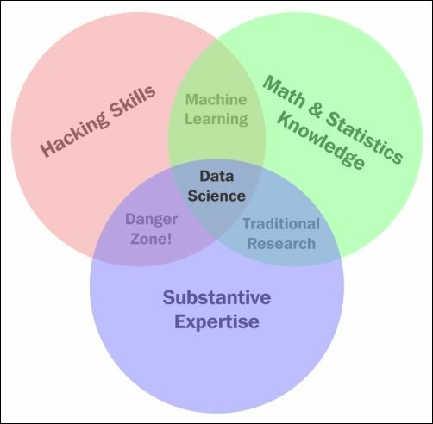Illustration 1: Venn Diagram of Data Science
Machine learning combines the power of computers with intelligent learning algorithms in order
to automate the discovery of relationships in data and create a powerful data models.

basic types of data models:
Probabilistic model: This refers to using probability to find a relationship between elements that
includes a degree of randomness.
Statistical model: This refers to taking advantage of statistical theorems to formalize
relationships between data elements in a (usually) simple mathematical formula.

Topic models:

Exploratory data analysis (EDA) refers to preparing data in order to standardize results and
gain quick insights.
EDA is concerned with data visualization and preparation. This is where we turn unorganized
data into organized data and also clean up missing/incorrect data points. During EDA, we will
create many types of plots and use these plots to identify key features and relationships to exploit
in our data models.
Data mining is the process of finding relationships between elements of data.
Data mining is the part of data science where we try to find relationships between variables

Whenever you are faced with a new dataset, the first three questions you should ask about it are the
following:
- Is the data organized or unorganized?
For example, does our data exist in a nice, clean row/column structure?
- Is each column quantitative or qualitative?
For example, are the values numbers, strings, or do they represent quantities?
- At what level of data is each column?
For example, are the values at the nominal, ordinal, interval, or ratio level?

Type of Data

Structured (organized) data: This is data that can be thought of as observations and
characteristics. It is usually organized using a table method (rows and columns).
Unstructured (unorganized) data: This data exists as a free entity and does not follow any
standard organization hierarchy.

Quantitative versus qualitative data
Quantitative data: This data can be described using numbers, and basic mathematical
procedures, including addition, are possible on the set.
Qualitative data: This data cannot be described using numbers and basic mathematics. This
data is generally thought of as being described using "natural" categories and language.

Quantitative data can be broken down, one step further, into discrete and continuous quantities.

Discrete data: is based on counts, only a finite number of values is possible & the values cannot be subdiveded meaningfully.
Examples of discrete quantitative data include a dice roll, because it can only take on six values,
and the number of customers in a café, because you can't have a real range of people.

Continuous data: is information that can be measured on a continuum or scale.
Continues data can have almost any numeric values & can be meaning fully divided into finer & finer increament, depending upon the precision of the measurement system.

A good example of continuous data would be a person's weight because it can be 150 pounds or
197.66 pounds (note the decimals). The height of a person or building is a continuous number
because an infinite scale of decimals is possible. Other examples of continuous data would be
time and temperature.

Mean , Median and Mode are the three kinds of avergaes in Statistics

Mean : where you add up all the numbers & divide by Number of Numbers
Median : the “middle” value in the list of numbers. (you have to sort nos. from smallest to largest)
Mode : is the value that occurs most often (if No number in the list is repeated
Range : range of a list of numbers is just a difference between the largest & the smallest value

e.g. [13, 18, 13, 14, 13, 16, 14, 21, 13] --> Data set
Mean --> (13+18+13+14+13+16+14+21+13)/9 = 15
Median --> (13, 13, 13, 13, 14, 14, 16, 18, 21) = so the middle number would be (9+1)/2=10/2=5th
mode --> the number that is repeated more often than any other number, so it is 13
Range --> Difference between the largest & the smallest value in the list S 21- 13 = 8

The four levels of data

structured data can be broken down into one of four levels of data. The levels are:

1. The nominal level : consists of data that is described purely by name or category. Basic examples include gender, nationality, species, They are not described by numbers and are therefore qualitative.
e.g. A type of animal is on the nominal level of data. We may also say that if you are a chimpanzee,
then you belong to the mammalian class as well
Of course, being qualitative, we cannot perform any quantitative mathematical operations, such as
addition or division. These would not make any sense.

We cannot perform mathematics on the nominal level of data except the basic equality and set
membership functions, as shown in the following example:
Being a tech entrepreneur is the same as being in the tech industry, but not vice versa

A measure of center is a number that describes what the data tends to. It is sometimes referred to as the balance point of the data. Common examples include the mean, median, and mode.
In order to find the center of nominal data, we generally turn to the mode (the most common element) of the dataset. For example, look back at the WHO alcohol consumption data. The most common continent surveyed was Africa, making that a possible choice for the center of the continent column.
Measures of center such as the mean and median do not make sense at this level as we cannot order
the observations or even add them together.

2. The ordinal level : Data in the ordinal level provides us with a rank order, or the means to place one observation before the other; however, it does not provide us with relative differences between observations, meaning that while we may order the observations from first to last, but we cannot add or subtract them to get any real meaning.

e.g. Whenever you are given a survey asking you to rate your satisfaction on a scale from 1 to 10, you are providing data at the ordinal level. Your answer, which must fall between 1 and 10, can be ordered
However, differences between the numbers do not make much sense

It inherit all mathematics from the Nominal level (equality and set membership) and we can also add the following to the list of operations allowed in the Ordinal level.
- Ordering : Ordering refers to the natural order provided to us by the data;
When speaking about the spectrum of visible light, we can refer to the names of colors
—red, orange, yellow, green, blue, indigo, and violet. Naturally, as we move from left to right, the light is gaining energy and other properties. We may refer to this as a natural order.
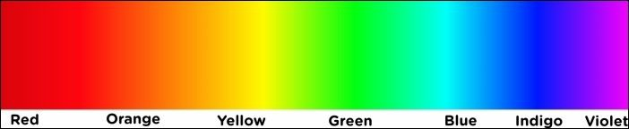
- However, if needed, an artist may impose another order on the data, such as sorting the colors based on the cost of the material to make the said colorComparison : At the ordinal level, we can make these comparisons. For example, we can talk about how putting a "7" on a survey is worse than putting a "10".

measure of center : At the ordinal level, the median is usually an appropriate way of defining the center of the data. The mean, however, would be impossible because division is not allowed at this level. We can also use the mode like we could at the nominal level.

3. The interval level : Data at the interval level allows meaningful subtraction between data points.
e.g. If it is 100 degrees Fahrenheit in Texas and 80 degrees Fahrenheit in Istanbul, Turkey, then Texas is 20 degrees warmer than Istanbul.
We can use all the operations allowed on the lower levels (ordering, comparisons, and so on),
alongwith two other notable operations:
- Addition
- Subtraction

measure of center: At this level, we can use the median and mode to describe this data; however, usually the most accurate description of the center of data would be the arithmetic mean

Measures of variation (like the standard deviation):In data science, it is also very important to mention how "spread out" the data is. The measures that describe this phenomenon are called measures of variation

Standard deviation : Standard deviation is the most common measure of variation of data at the interval level and beyond. The standard deviation can be thought of as the "average distance a data point is at from the mean". While this description is technically and mathematically incorrect, it is a good way to think about it. The formula for standard deviation can be broken down into the following steps:

1. Find the mean of the data.
2. For each number in the dataset, subtract it from the mean and then square it.
3. Find the average of each square difference.
4. Take the square root of the number obtained in step three. This is the standard deviation.

4. The ratio level : The ratio level proves to be the strongest of the four. Not only can we define order and difference, the ratio level allows us to multiply and divide as well.

e.g, 1. A measurement zero Kelvin literally means the absence of heat. It is a non-arbitrary
starting zero. We can actually scientifically say that 200 Kelvin is twice as much heat as 100 Kelvin.
2. Money in the bank is at the ratio level. You can have "no money in the bank" and it makes sense that $200,000 is "twice as much as" $100,000.

Measures of center : The arithmetic mean still holds meaning at this level, as does a new type of mean called the geometric mean. This measure is generally not used as much even at the ratio level, but is worth mentioning. It is the square root of the product of all the values.

The Five Steps of Data Science

The five essential steps to perform data science are as follows:
1. Asking an interesting question : Start writing down questions regardless of whether or not you think the data to answer these questions even exists.
2. Obtaining the data: Once you have selected the question you want to focus on, it is time to scour the world for the data that might be able to answer that question. As mentioned before, the data can come from a variety of sources; so, this step can be very creative!
3. Exploring the data : Once we have the data, we use the lessons learned in Chapter 2, Types of Data, of this book and begin to break down the types of data that we are dealing with. This is a pivotal step in the process. Once this step is completed, the analyst generally has spent several hours learning about the domain, using code or other tools to manipulate and explore the data, and has a very good sense of what the data might be trying to tell them.
4. Modeling the data: This step involves the use of statistical and machine learning models. In this step, we are not only fitting and choosing models, we are implanting mathematical validation metrics in order to quantify the models and their effectiveness.
5. Communicating and visualizing the results : This is the most important step. While it might seem obvious and simple, the ability to conclude your results in a digestible format is much more difficult than it seems.

Steps to Explore the data

The process of exploring data is not defined simply. It involves below steps
- Recognize the different types of data
- Transform data types
- and use code to systemically improve the quality of the entire dataset to prepare it for the modeling stage

Basic questions for data exploration
Is the data organized or not? - whether or not the data is presented in a row/column structure.
What does each row represent? - we should identify what each row actually represents. This step is usually very quick, and can help put things in perspective much more quickly
What does each column represent? - We should identify each column by the level of data and whether or not it is quantitative/qualitative, and so on. This categorization might change as our analysis progresses, but it is important to begin this step as early as possible.
Are there any missing data points? - Data isn't perfect. Sometimes we might be missing data because of human or mechanical error. When this happens, we, as data scientists, must make decisions about how to deal with these discrepancies.
Perform an isnull operation. For example if your dataframe is called awesome_dataframe then
try the python command awesome_dataframe.isnull().sum() which will show the number of
missing values in each column.
Do we need to perform any transformations on the columns? - Depending on what level/type of data each column is at, we might need to perform certain types of transformations.
e.g. for the sake of statistical modeling and machine learning, we would like each column to be numerical.

